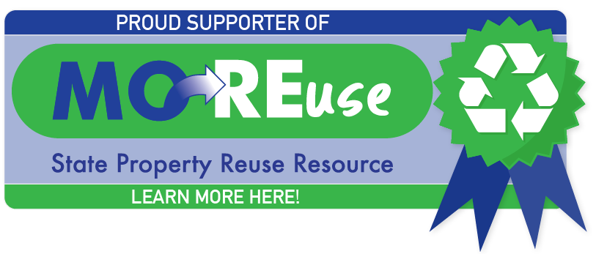
Spread the word!
Instructions on how to place the MOREuse badge in your email signature
MOREuse is a great tool for state team members to give and take items without incurring the cost of purchasing “new” To show how savvy you are and your support for sustainable practices, we are offering an email signature badge for team members who participate in MOREuse. This is a completely optional show of support. Please make sure your Department doesn’t have restrictions on the use of images in your email signature before using.
You may update your signature using the attached image by following these easy steps:
- Copy the image from this document.
- Open Microsoft Outlook and click on New Email.
- In the Insert tab, go to Signature> and drop down to Signatures.
- In the edit signature field, paste the image you copied in Step 1 to the bottom of your email signature.
- Select OK.
- Close the draft email, and open a new one. The badge should now show up in your email signature.
To hyperlink the badge image, you may select the image in the edit signature field, select the hyperlink button (), then type https://oa.mo.gov/moreuse in the Address field at the bottom, then select OK.

Thank you for your support of MOREuse!

